NEW MEXICO ASSOCIATION OF COUNTIES
Inmate Intake Screening Form
(Revised: January 23, 2013)
I. SUBSTANCE USE/ABUSE
- Signs of being under the influence of Alcohol/Drugs ( Specify Symptoms) Yes No
- Signs of Substance Withdrawal: Yes No
- Do you use alcohol/drugs: Type:___________ Yes No
- Amount consumed regularly _____________
- Amount consumed in last 24 hours__________
- Are you currently taking methadone/suboxin: Yes No
- Are you currently taking prescription medication: Yes No
- Your own: If yes, what:________; how often:_______; last used:_____________
- Someone else’s; If yes, what:_______; how often:______; last used:__________
- Do you get sick when you stop using alcohol/drugs: Yes No
Symptoms experienced:________________________________________
COMMENTS:_______________________________________________________________________________________________________________________________________________________________________________________________________________________________

II. SUICIDE RISK
- Have you felt like hurting yourself in the past: Yes No
- If so, when and how_____________________________
- Do you feel like hurting or killing yourself now (suicide or self-harm): Yes No
- Has there been anyone in your family or close friend
who has attempted or committed suicide: Yes No
- Have you ever been treated for depression or other mental
health issues: Yes No
- If so, when and what____________________________
- Have you suffered a recent loss of someone in your life: Yes No
- IF so, who and when____________________________
- Observations of staff:
- Is subject stressed or embarrassed: Yes No
- Is subject nervous or restless: Yes No
- Is subject withdrawn or non-communicative: Yes No
- Does subject appear to have minimum levels of consciousness: Yes No
- Informational:
- Does the arresting or transporting officer/s have
concerns regarding the subject’s threat to self or threat to other Yes No
- Was the subject a prior suicide risk during previous
contact or confinement with the agency Yes No
- Has inmate reported LOC: If yes, when:___________ Yes No
NOTICE: A ‘YES’ to any of the above 8 statements requires a MANDATORY
REFERRAL for further evaluation.
COMMENTS:_________________________________________________________________________________________________________________________________________________

III. MENTAL HEALTH SCREENING: (MUST be completed by Medical/MH Professional Staff)
- Does the subject display behavior indicating being mentally challenged: Yes No
- Does the subject show signs of:
- Depression Yes No
- Anxiousness Yes No
- Anger Yes No
- Fear Yes No
- Does the subject hold a position of respect or authority in the community: Yes No
- If so, add to risk of suicide________________________
- Has the subject suffered a traumatic brain injury: Yes No
- If so, when and how_____________________________
- Is the subject now or in the past on psychotropic medications: Yes No
- If so, what and when______________________________
- Is the subject now or in the past treated or hospitalized for
behavioral health reasons? Yes No
- If so, for what and when_____________________________
- Subjective Mental Health Observations:
Facial: Normal Sad Flat Worried Avoids gaze Other
Dress: Normal Meticulous Poor hygiene Eccentric Seductive Other
Motor Activity: Normal Agitation Tremors Muscle stiffness Other
Speech: Normal Slurred Slowed Rapid Stuttering Other
Interview Behavior: Normal Angry Impulsive Withdrawn Passive Other
Flow of Thought: Normal Flight of ideas Loose association Other
Mood/Affect: Normal Anxious Flat Elevated Depressed Other
Orientation: Time __ Place __ Person __ Event __
Insight/Judgment: Normal Doesn’t know why he/she is here
Thought Content: Appears to have visual and/or auditory hallucinations

COMMENTS:_______________________________________________________________________________________________________________________________________________________________________________________________________________________________

IV. PREA CONCERNS
(
All information obtained in this section will be included in the final decision for custody status and housing assignment upon completion of the Initial Screening Form, Initial Custody Assessment Scale, and the Custody Reassessment Scale, respectively.)

1. Has the inmate/detainee been involved in a sexual related offense prior to detention or
while in detention either as a victim or as an assailant? Yes No
COMMENTS:_______________________________________________________________________________________________________________________________________________________________________________________________________________________________

2. Potential Risk of Victimization – MALE inmate/detainee’s information:
- Mental or physical disability Yes No
- Young Age Yes No
- Slight Build Yes No
- First incarceration in detention Yes No
- Non-violent offense or history Yes No
- Sexual orientation of gay or bisexual Yes No
- Gender non-conformance (e.g., transgender or intersex identity) Yes No
- Prior sexual victimization Yes No
COMMENTS:_______________________________________________________________________________________________________________________________________________________________________________________________________________________________

3. Potential Risk of Victimization – FEMALE inmate/detainee’s information:
- Mental or physical disability Yes No
- First incarceration in detention Yes No
- Sexual orientation of gay or bisexual Yes No
- Prior sexual victimization Yes No
- Inmate’s/detainee’s own perception of vulnerability Yes No
COMMENTS:_______________________________________________________________________________________________________________________________________________________________________________________________________________________________

4. Potential Risk for Sexual Predatory Behavior – Both MALE & FEMALE:
- Current charges are related to sexual assault and/or aggressive behavior Yes No
- Conviction for sex offenses against adults or children Yes No
- Prior acts of sexual abuse Yes No
- Prior convictions for violent offenses Yes No
- Prior acts of sexually aggressive behavior while in detention Yes No
Prior acts of violence against other inmates while in detention Yes No COMMENTS:_______________________________________________________________________________________________________________________________________________________________________________________________________________________________________________________________________________________________________

V. MEDICAL HEALTH SCREENING: (MUST be completed by Medical Professional Staff)
- Subject’s Vitals:
Temperature:_____HR:_____RR:_____O2SAT:_____BP:_____Hgt.:_____Wgt.:_____
- Have you just come from the Emergency Room, Doctor’s Office,
or medical furlough? Head Trauma?___ LOC:____ Yes No
- If so, what for:__________________________________
- Do you have medical or dental problems needing immediate attention: Yes No
- If so, what:_____________________________________
- Do you wear glasses or contact lenses: Yes No
- Do you have them with you: Yes No
- Contact Lenses – provide solution, container, and pass/permit
- Glasses: Frame: Intact/Broken Lenses: Intact/Broken
- Medical History as Reported by Subject/Inmate:
- Current treatment for medical problem: Yes No
- Use of prescription medication: Yes No
- Special prescribed diet: Yes No
- Recent hospitalization: Medical:___ Mental:___ Yes No
- Recent head injury: Yes No
- Recent blackouts/fainting: Yes No
- Unconscious: Yes No
- Reported Pain: Where?________ Onset:________ Tx:______ Yes No
- Chronic Cough: Yes No
- Chronic Diarrhea: Yes No
- Current itching/skin rash/open wounds/abscess: Yes No
- Bleeding/draining wounds: Yes No
- Heart condition: Yes No
- Diabetes: HTN:_______ Hyperlipidemia:_______ Yes No
- Epilepsy/seizures: Yes No
- Asthma: Yes No
- History of ulcers: Stomach:____ Skin:____ Yes No
- History of/Exposure to tuberculosis: Yes No
- History of/Exposure to sexually transmitted disease Yes No
- History of hepatitis/jaundice: Yes No
- AIDS/HIV: Yes No
- Allergies: Medications:____ Food:____ Environmental:_____ Yes No
- Dental problems: Yes No
- Physical handicap: Yes No
- Restricted mobility: Yes No
- Vermin: (Head-lice, Scabies, etc.) Yes No
- Lesions/bruises/other signs of physical injury: Yes No

COMMENTS:_________________________________________________________________________________________________________________________________________________ ______________________________________________________________________________

VI. FEMALE SPECIFIC:
- Are you pregnant? Yes No
- If so, how far along________________________________
- Have you started pre-natal care: Yes No
- Do you have a doctor: Yes No
  - If so, who__________________________________
- Have you recently had a baby, miscarriage, or abortion: Yes No
- If so, what procedure and when______________________

COMMENTS:_______________________________________________________________________________________________________________________________________________________________________________________________________________________________

VII. PHYSICAL INJURY CHART (Observable abrasions, abscesses, burns, contusions, lacerations, scratches, sprains, casts, tattoos, bruises, etc., UNHEALED OR NEW)
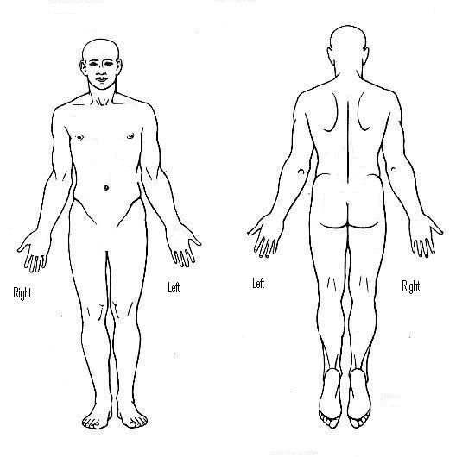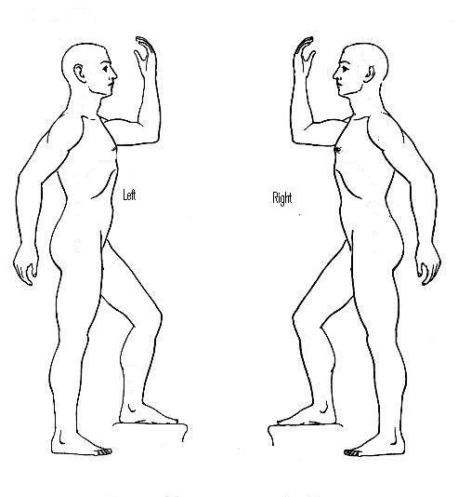
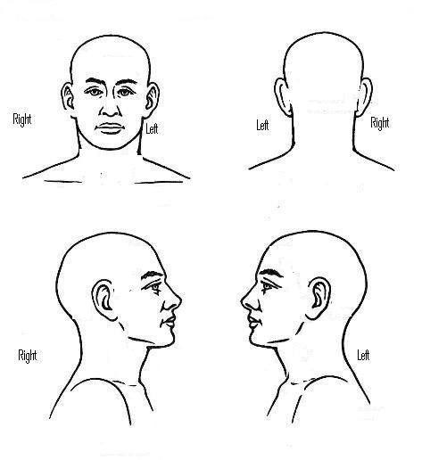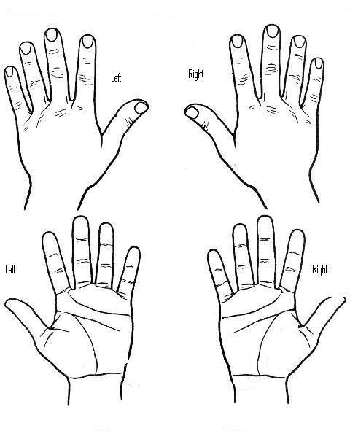

VIII. In case of an Emergency, who should we contact?
- Name:___________________________________
- Relation:_________________________________
- Phone:___________________________________
- Address:_________________________________
IX. Primary language spoken: English Spanish Other

