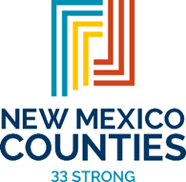  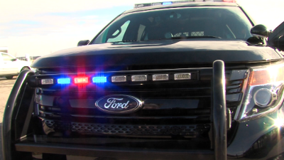  instructor training:  Verbal De-Escalation  MONDAY, NOVEMBER 13TH TO FRIDAY, NOVEMBER 17TH, 2023  Description  This 40-hour instructor training has been designed to provide a basic foundation in law enforcement instruction as well as the specialized knowledge necessary for verbal de-escalation of people in crisis. Participants will gain knowledge regarding how people respond or behave in crisis. This course is a NMDPS NMLEA accredited class.  Live scenarios with professional actors  LOCATION: PUBLIC SAFETY PSYCHOLOGY GROUP  8341 WASHINGTON ST. NE  ALBUQUERQUE, NM 87199  NMDPS Accreditation: 40 Hours of Instruction | To Register  Email:  lbarela@nmcounties.org  TRAINING DATES:  Monday, November 13th thru  Friday, November 17th, 2023  8am to 5pm daily  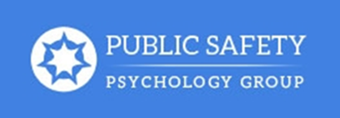  Public Safety Psychology Group  8341 Washington St. NE  Albuquerque, NM 87199  505-888-5499  www.pspg–nm.com

